1. Mismatch walk in count display in sales report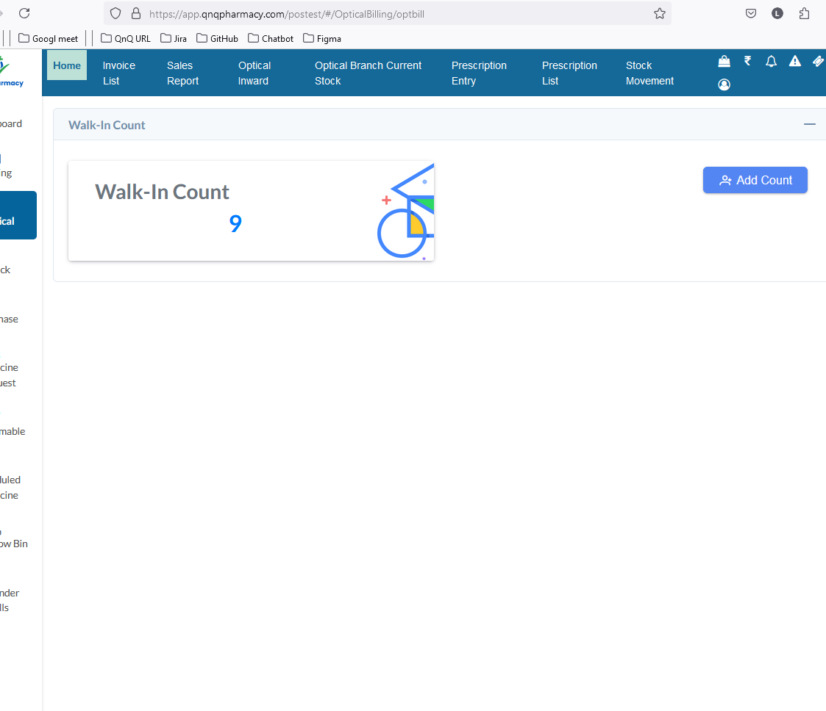//
2. Print button not working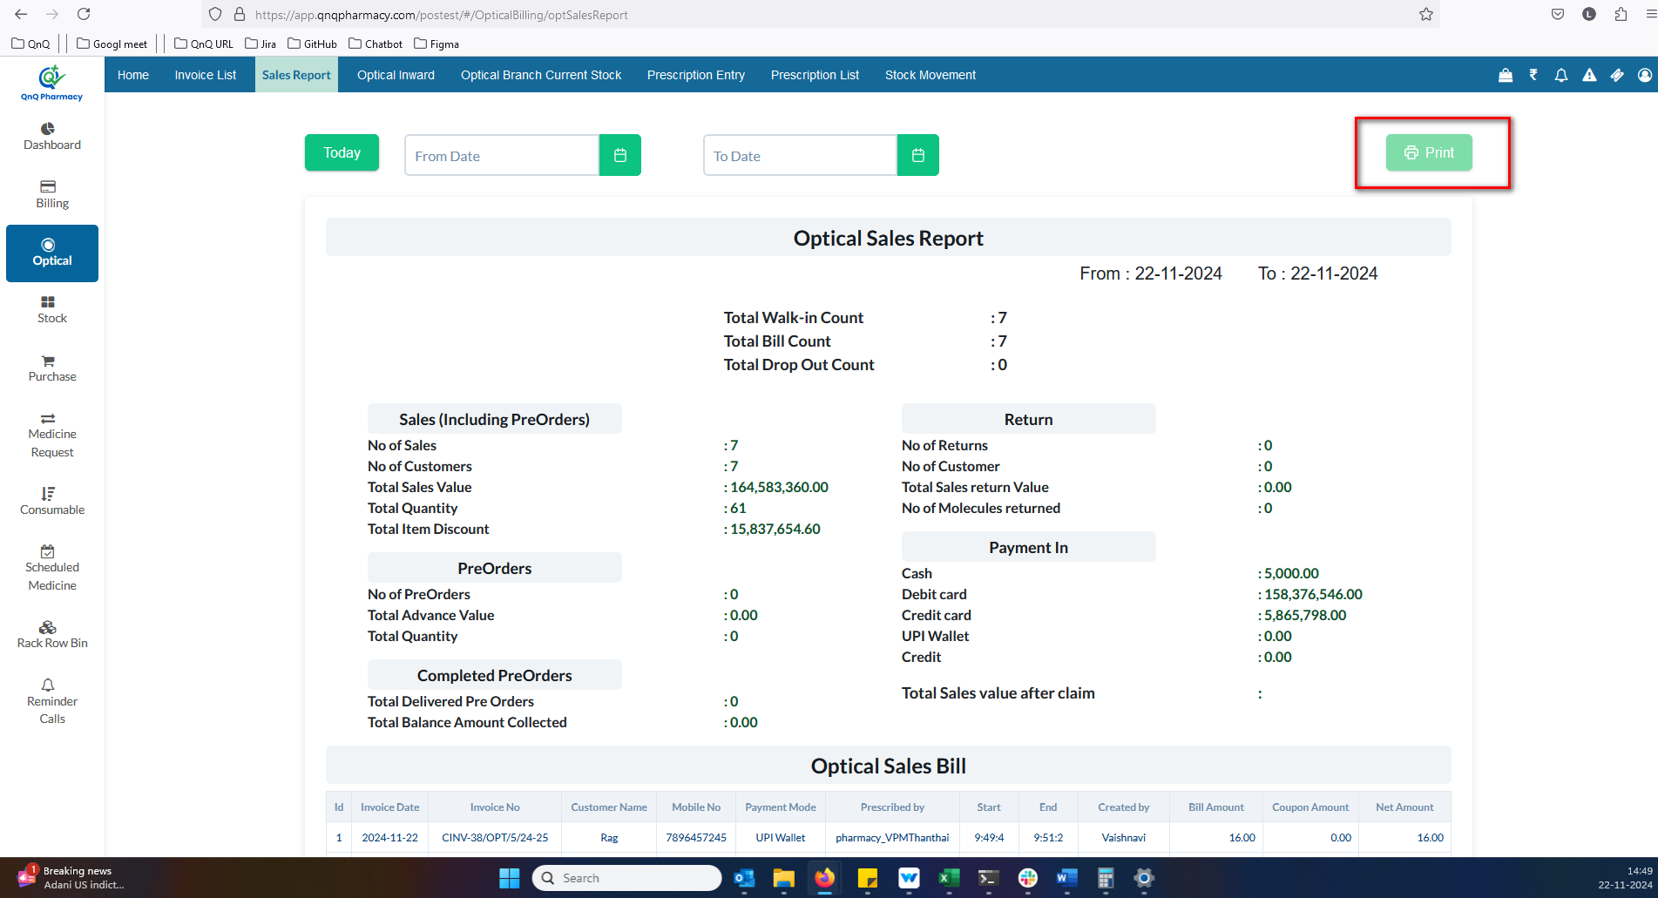//
3. Success message not display while fetch valid date value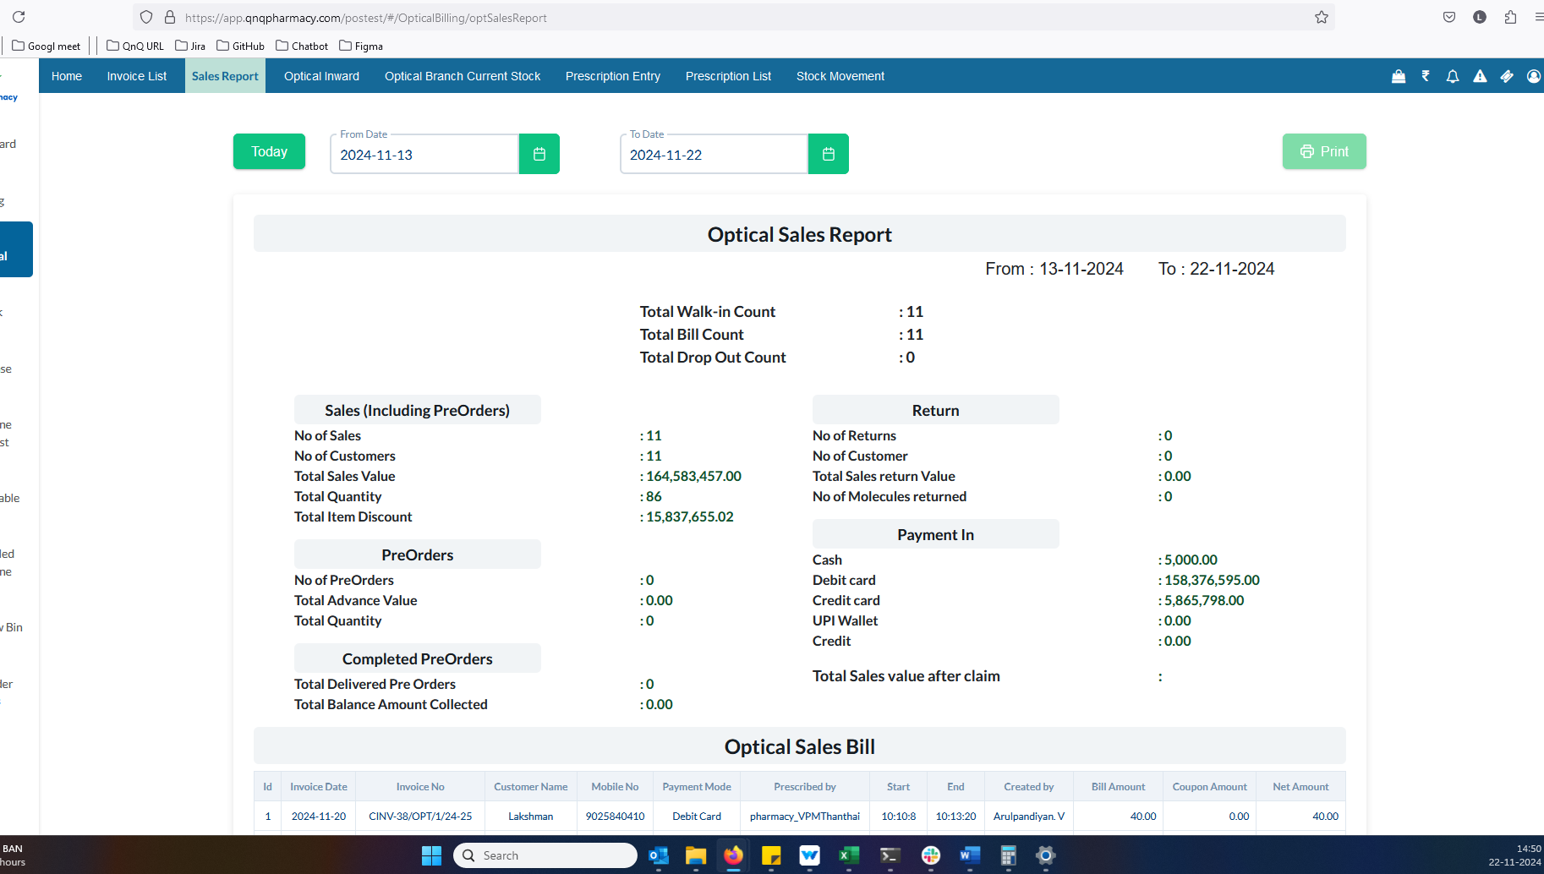//
4. Mismatch column name display in list grid 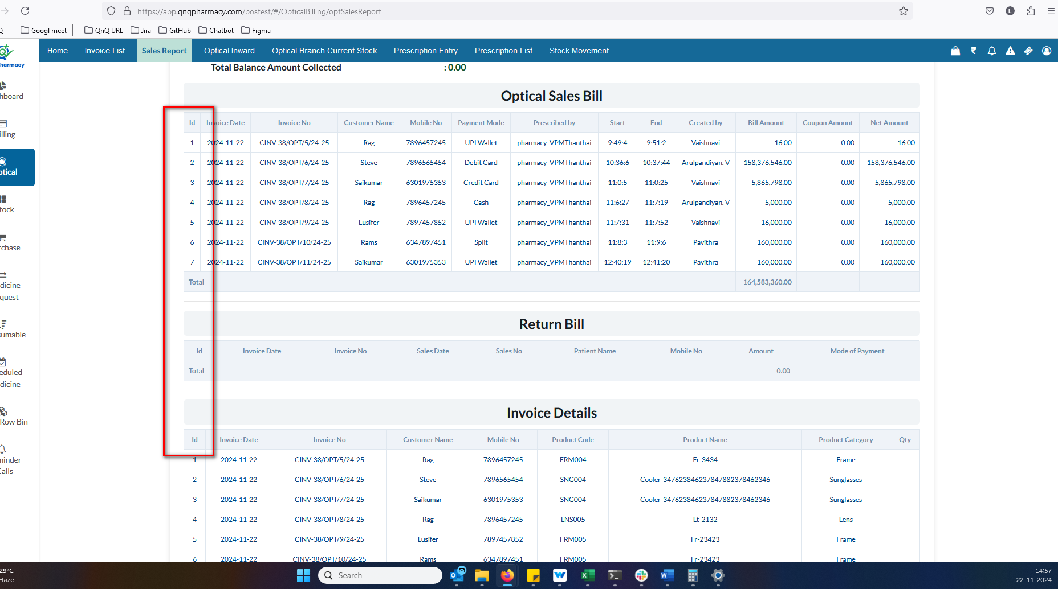//
5. UPI Wallet display as empty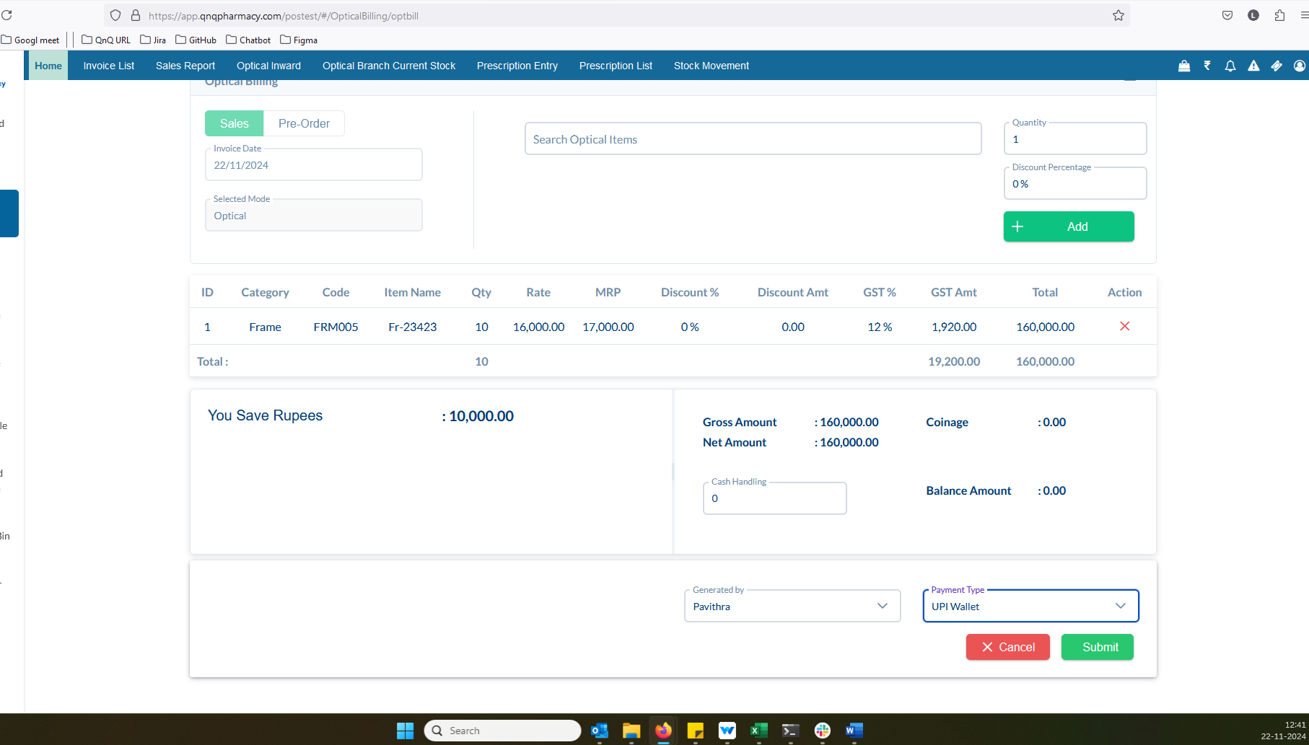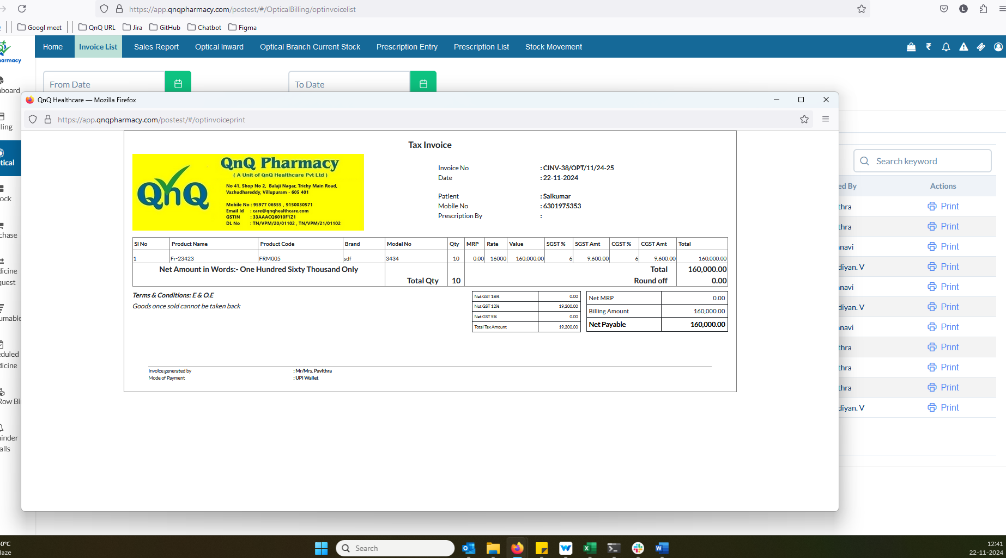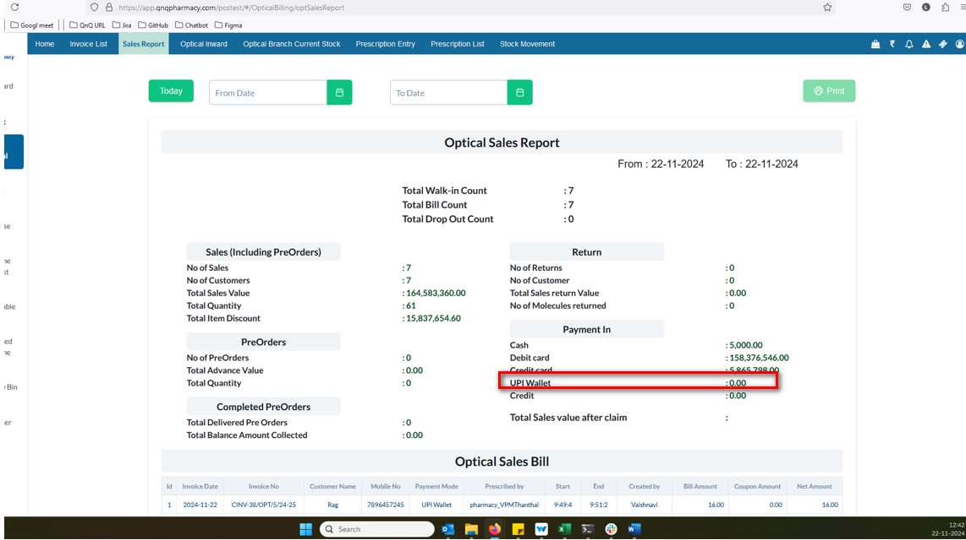//
6. Unwanted Credit column display in sales report page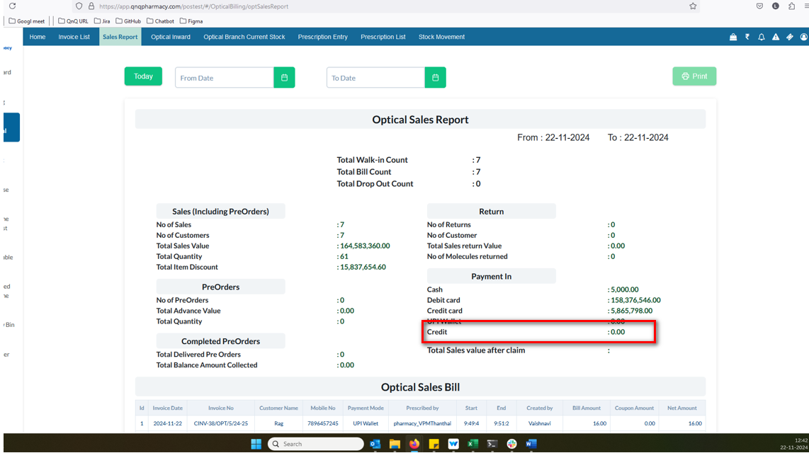//
7. Download options not displayed in the list grid 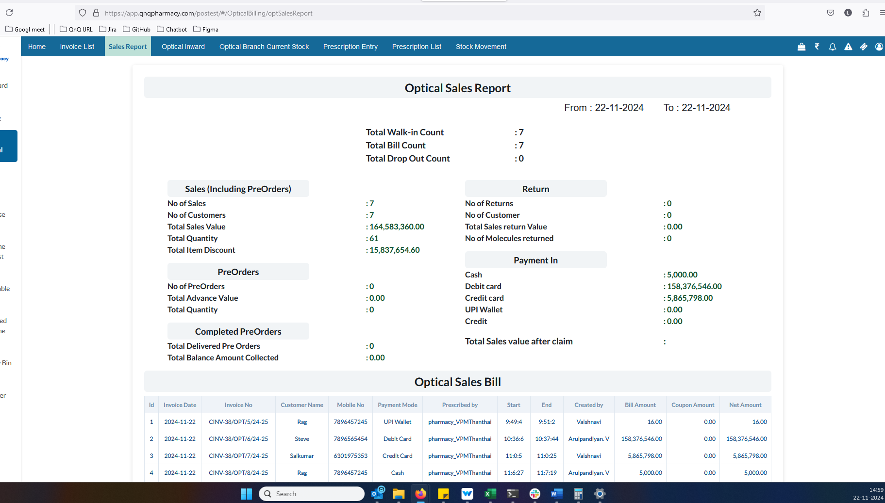//
8. Quantity value display as empty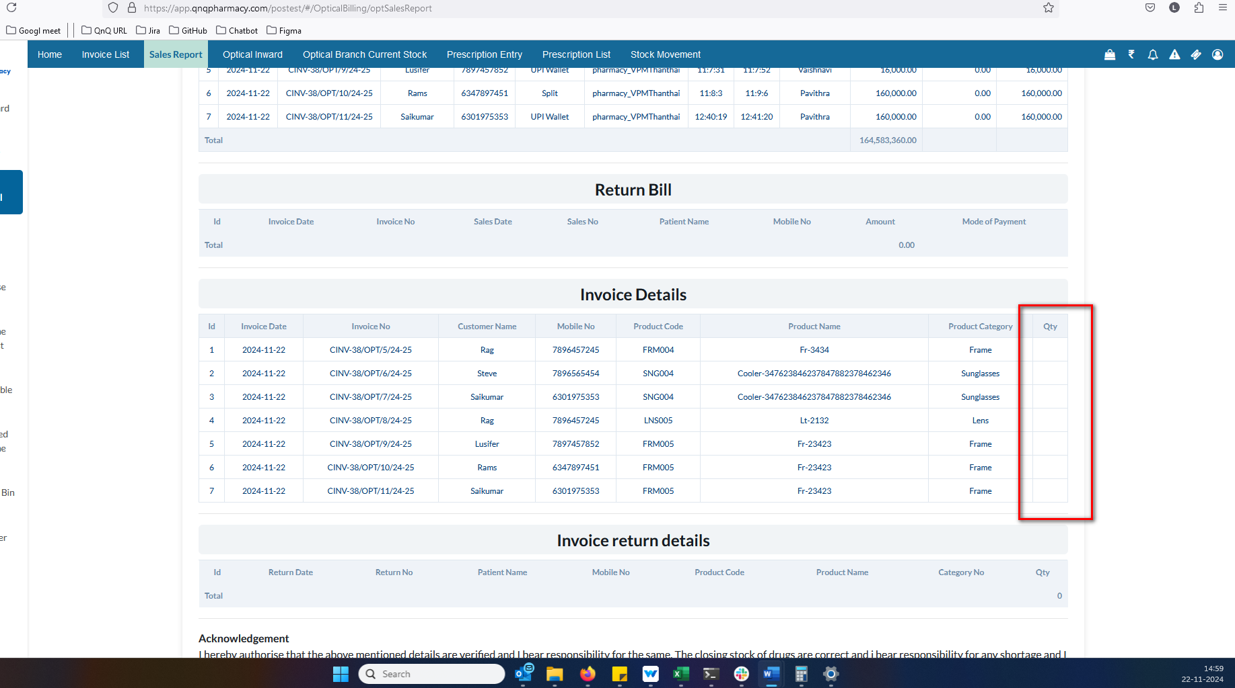//
9. Unwanted Return details section display in sales report page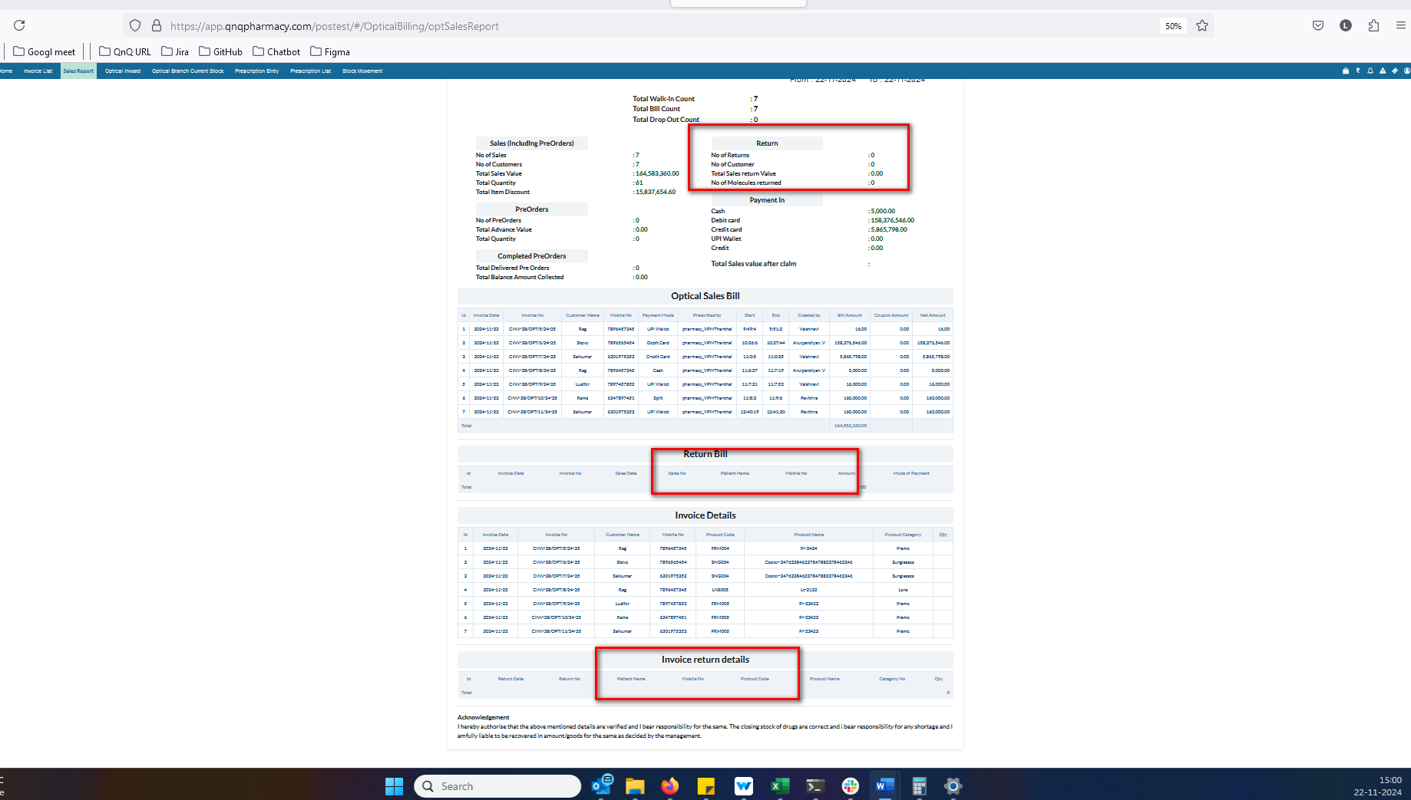//
10. Total Drop Out Count display as empty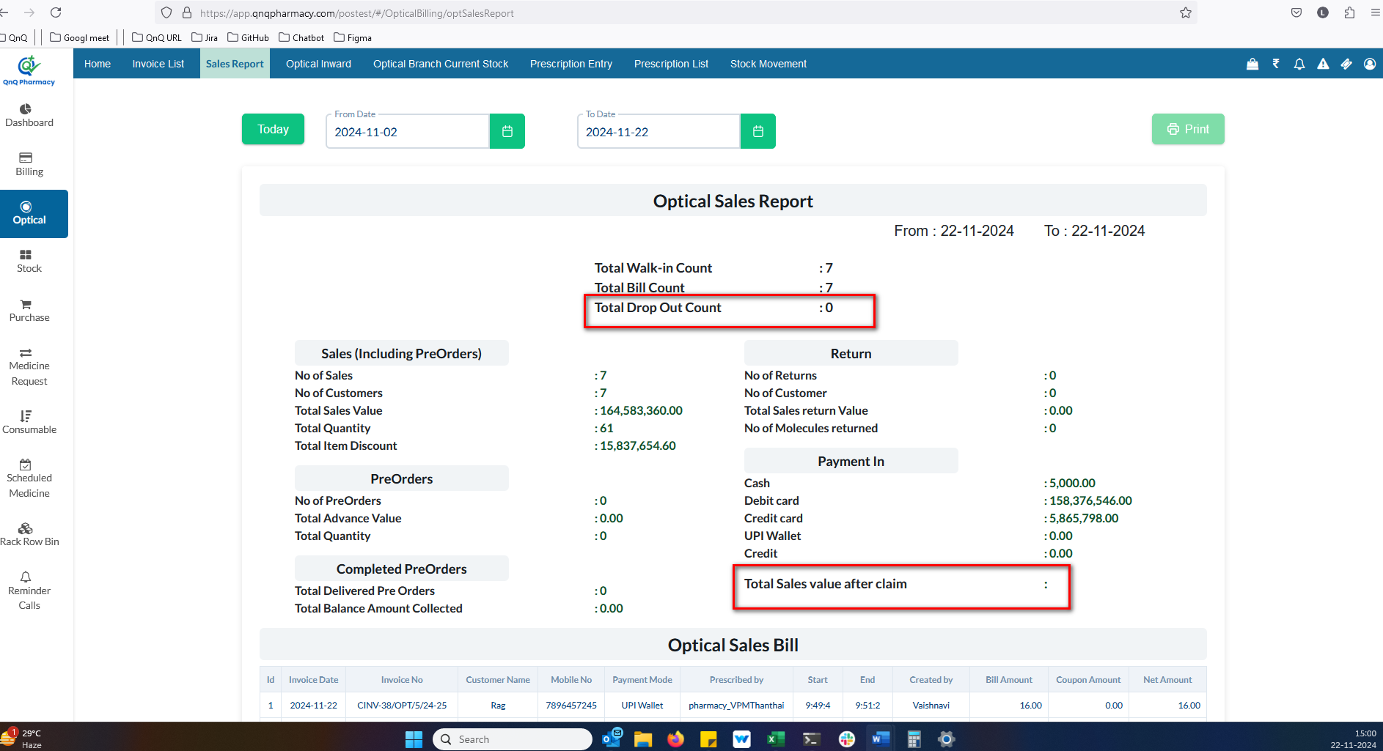//
11. Screen Title not display while navigate the page 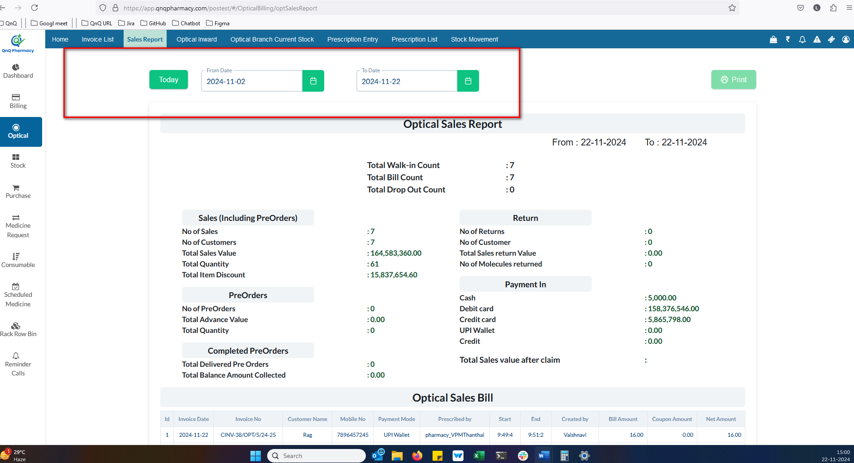//
12. Error message not display while invalid date range 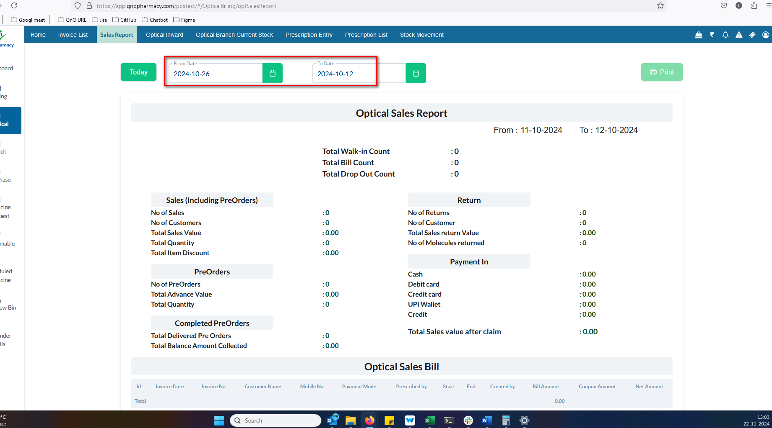//
13. Error message not display in Date field while give future date 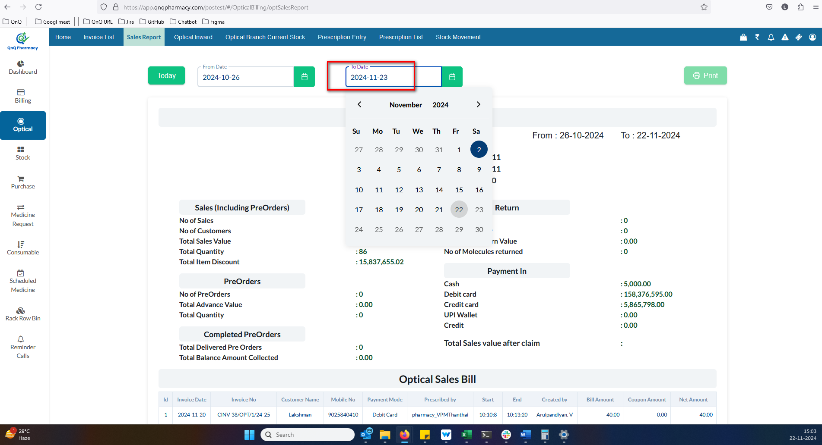//
14. Error highlighted colour display while click the Today button with the date values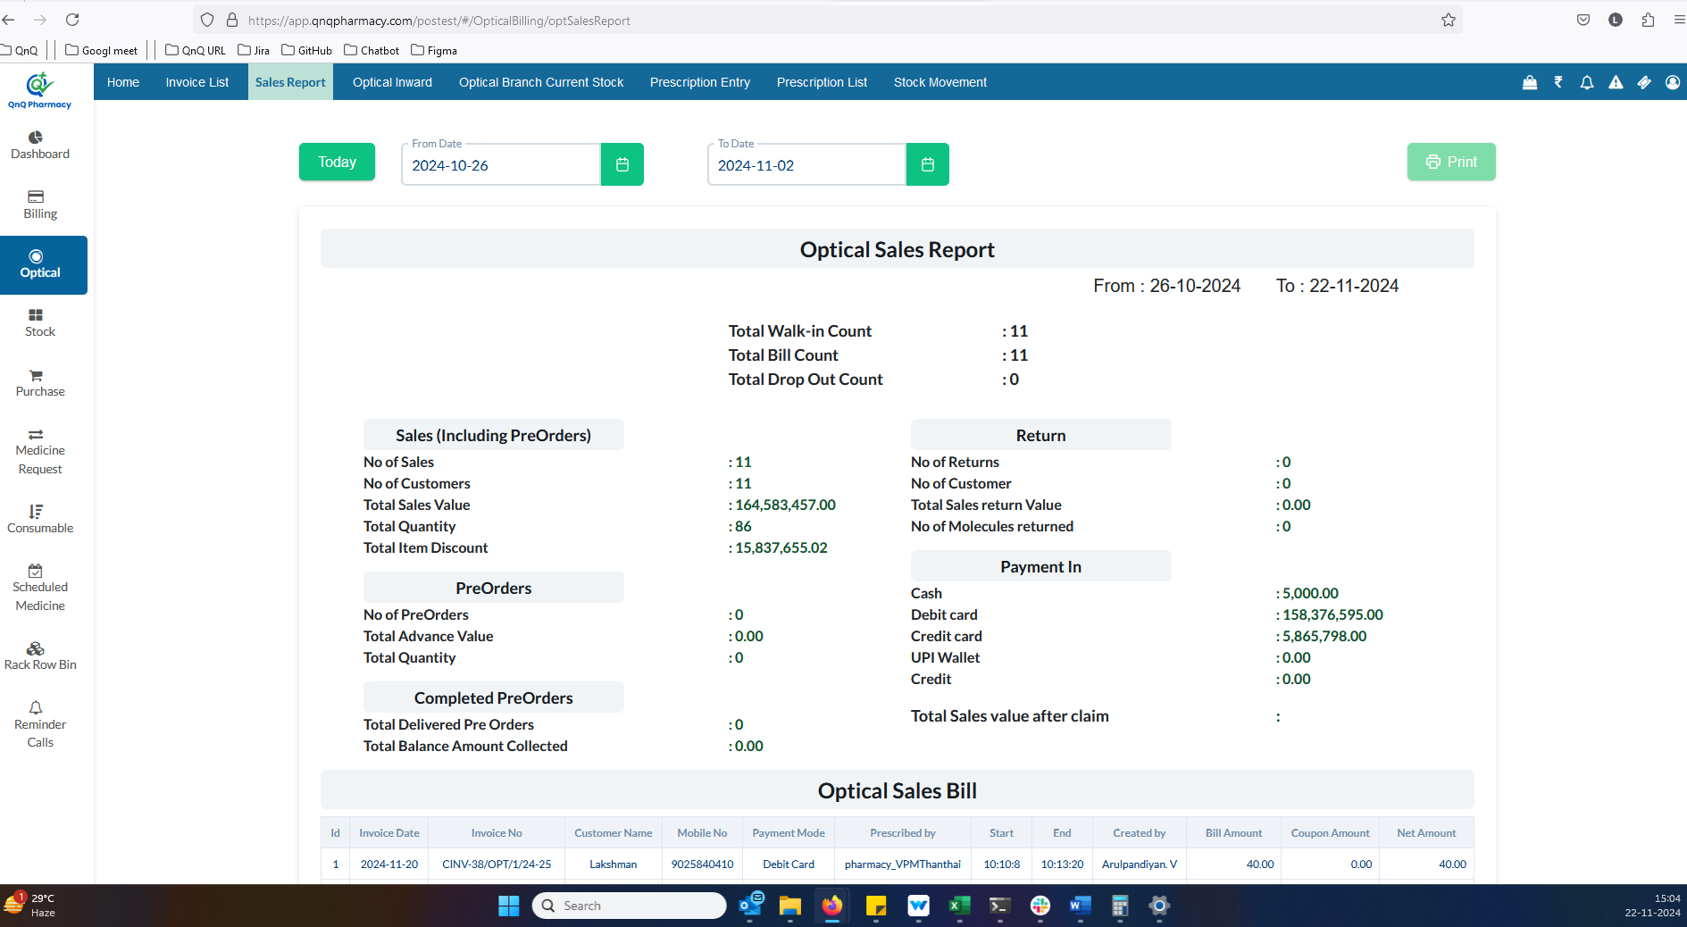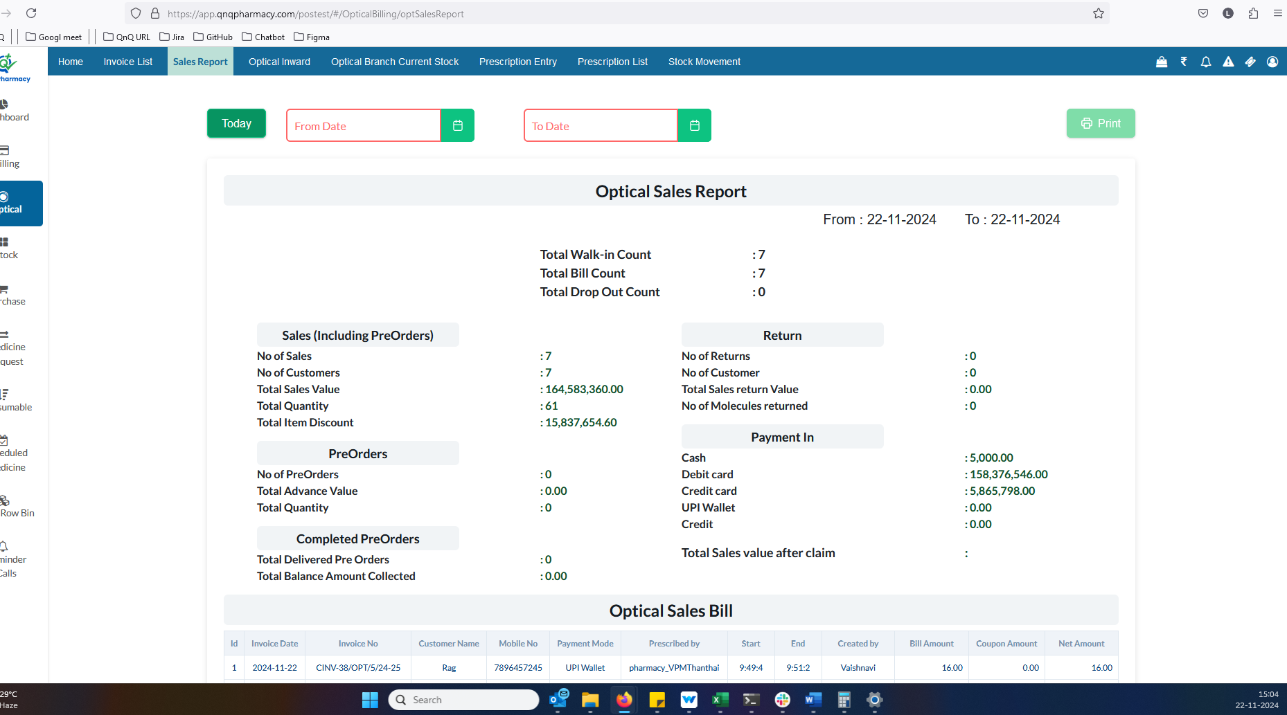//
15. Refresh icon not available for clear the search filter values 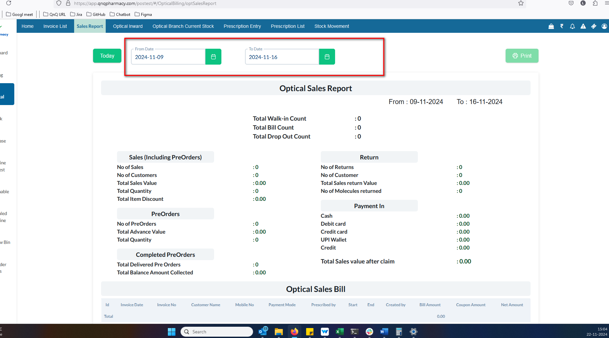//
16. Dot value not display short name field 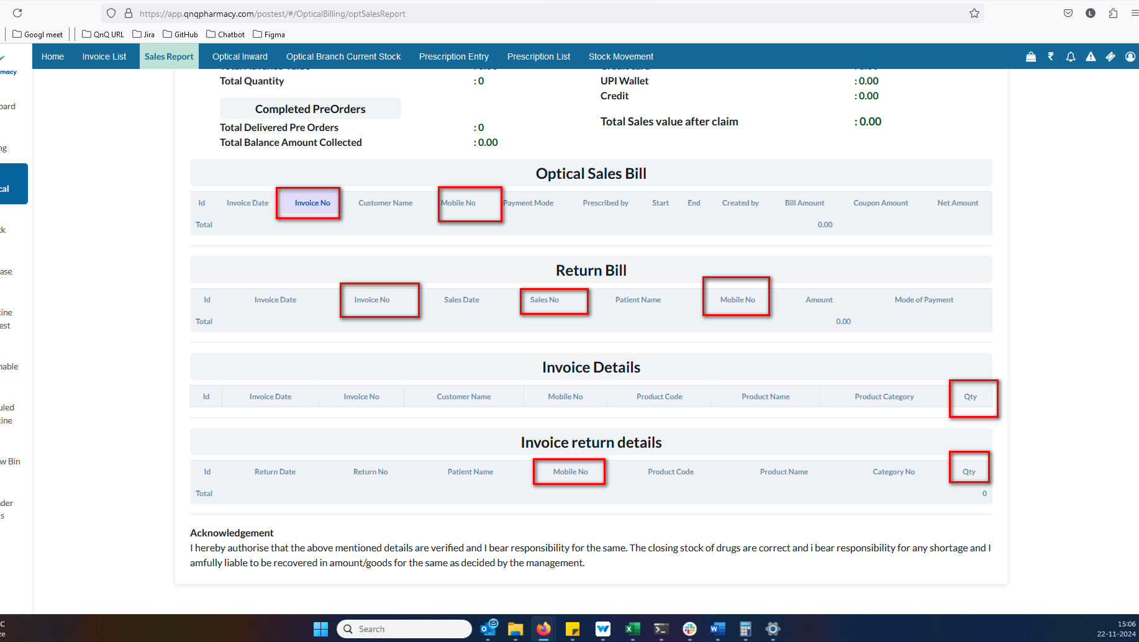//
17. Different date format display in list grid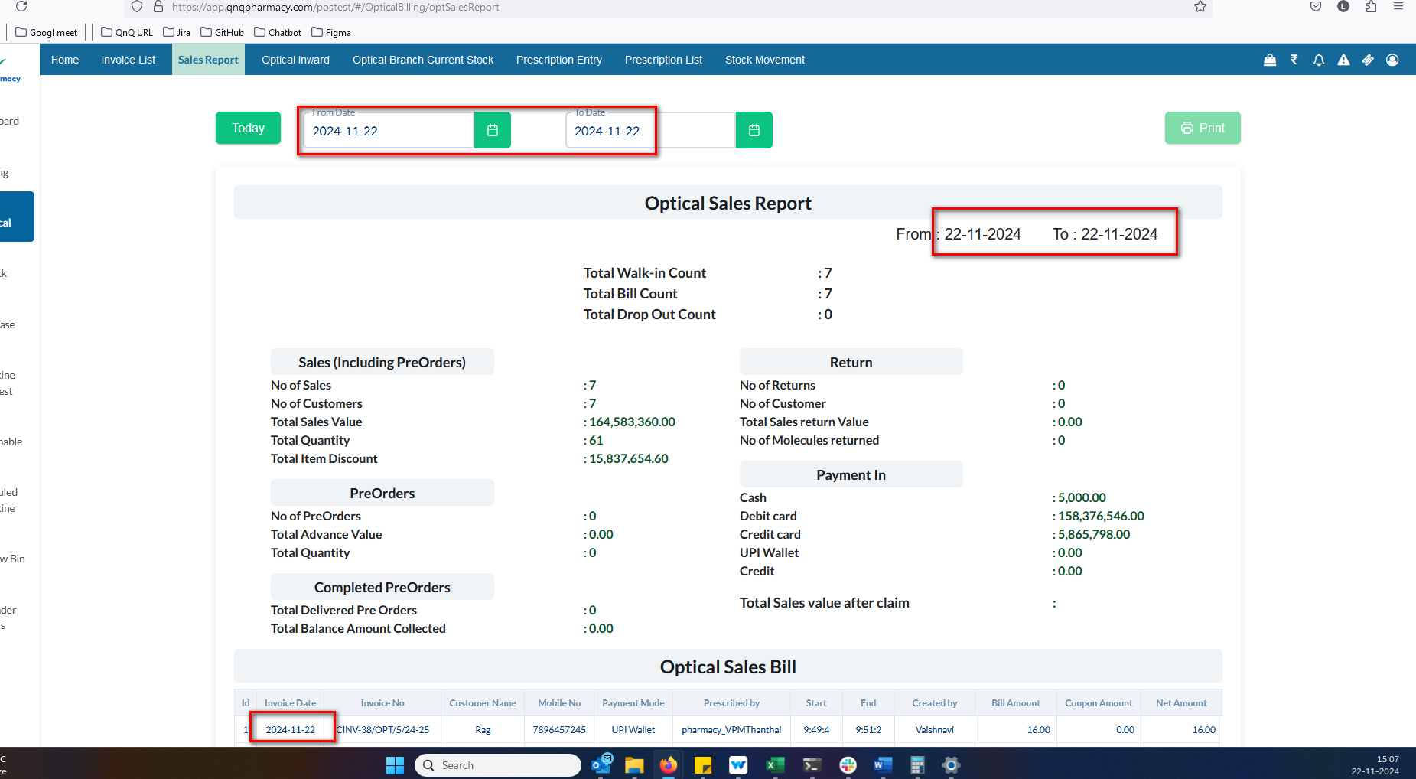//
18. The sorting feature is not functioning for any column 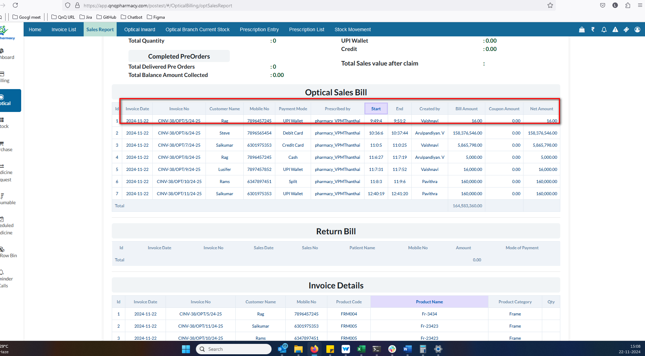//
19. No record available message not display in list grid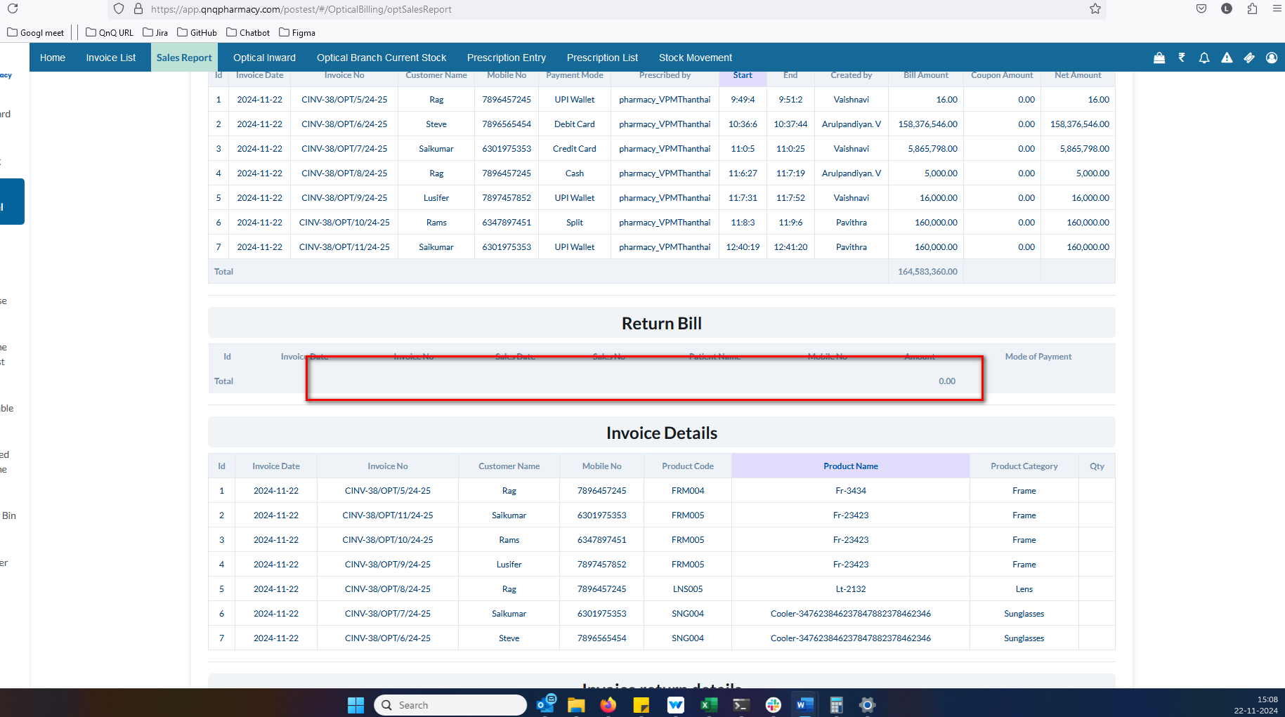 //
20. The pagination controls and count dropdown not display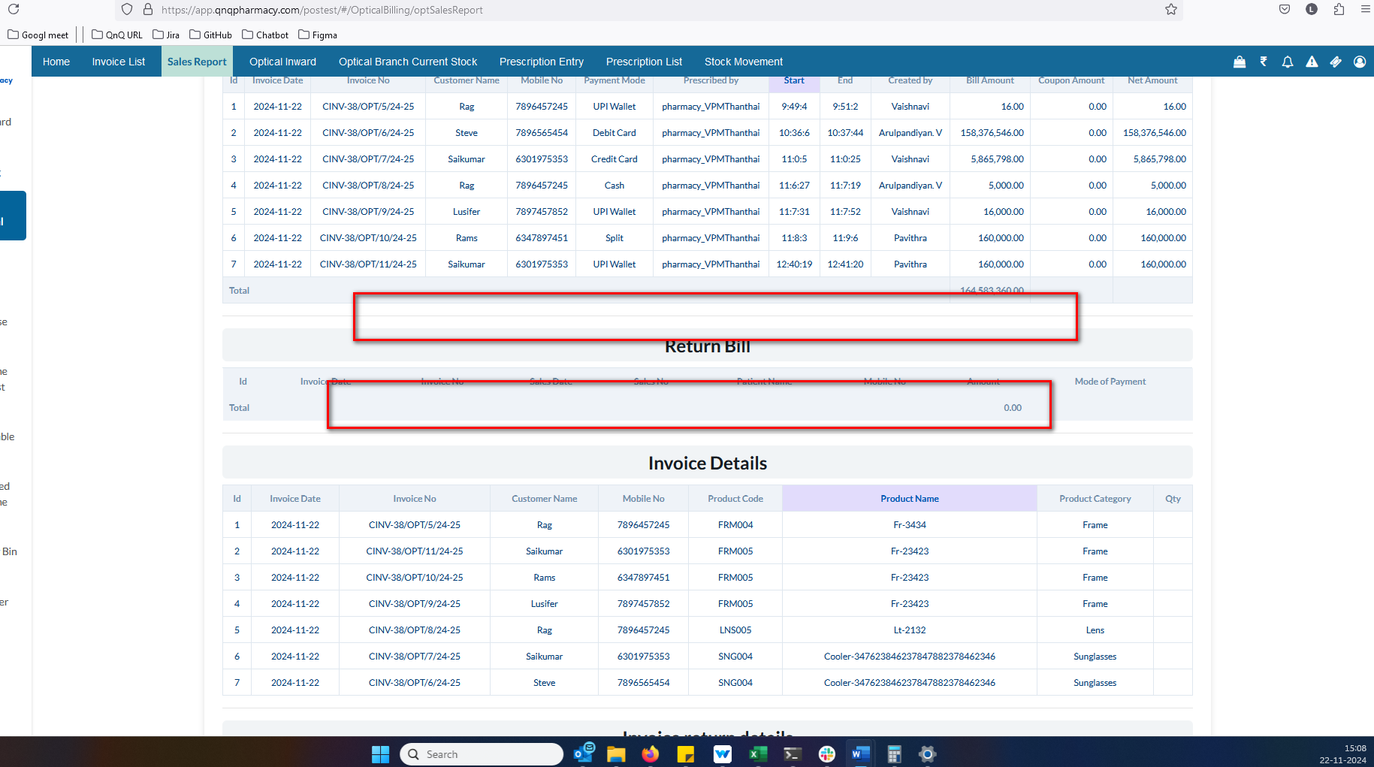 //
21. Sort icon not display in list column //
22. The label and value appear the same, with no difference between them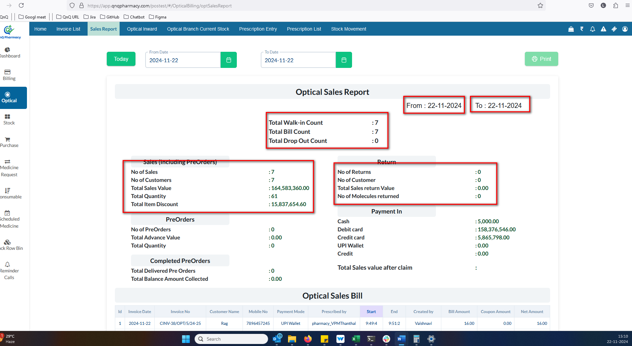//
23. The header and values are not differentiated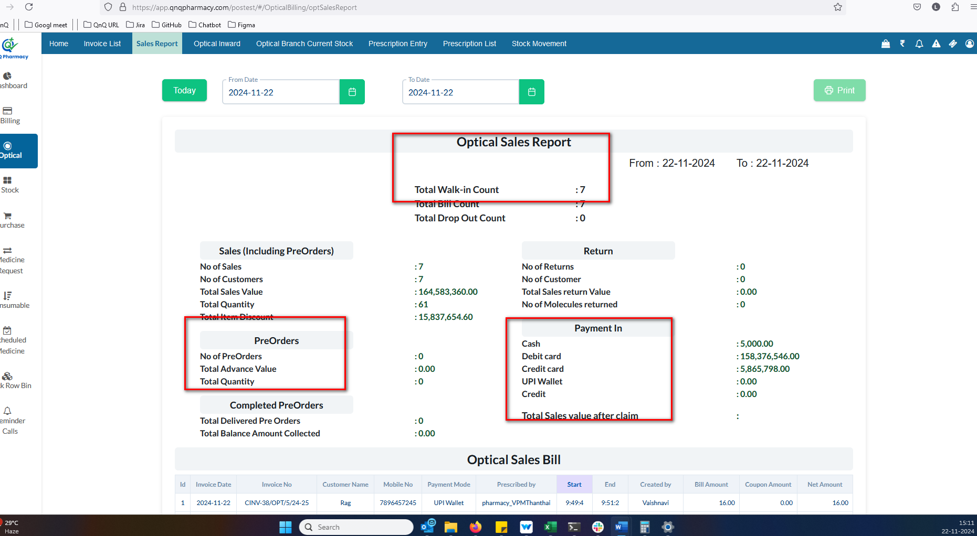//
24. An error indication appears when valid date values are pasted/clear 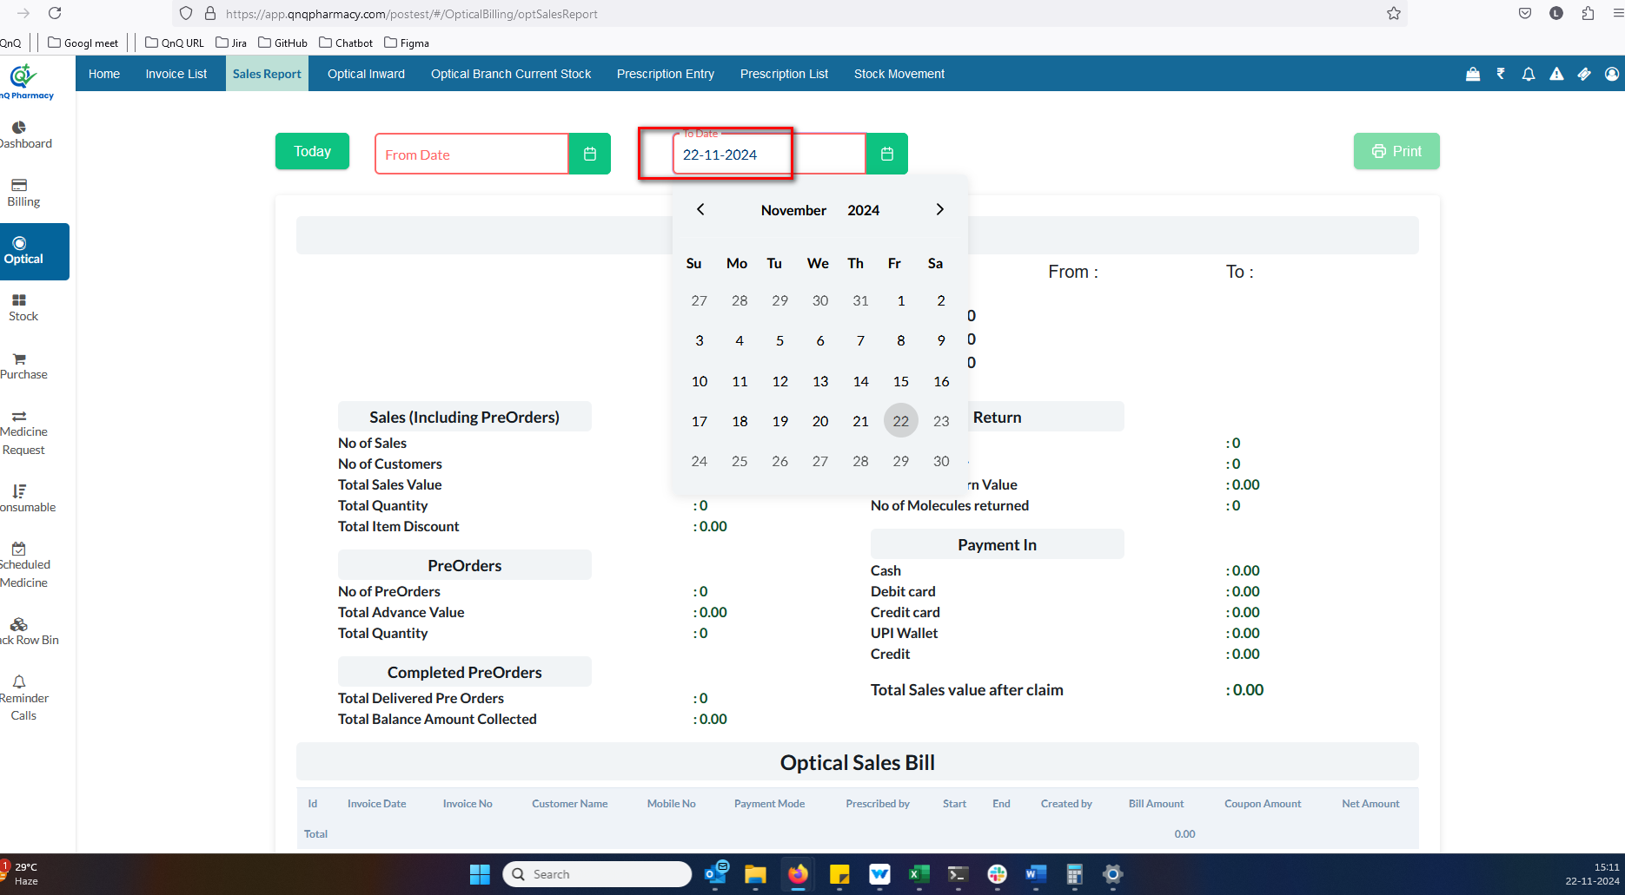 //
25. //
26. //
27. //
28. //
29. //
30. //
31. //